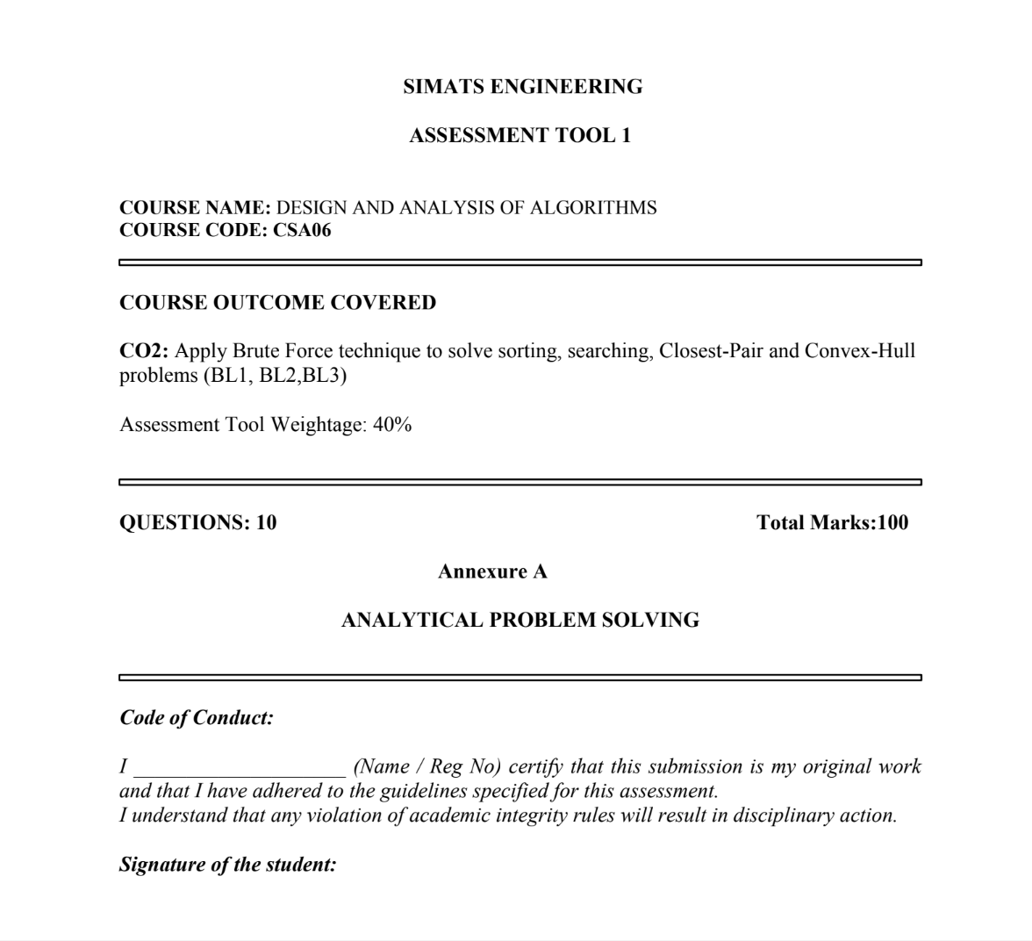

CSA0606-DESIGN AND ANALYSIS ALGORITHM
CO2-ASSIGNMENT TOOL-1
SUBMITTED BY : P Sudharshan Reddy(192372204)
Q.Bubble Sort on the Dataset [11, 11, 25, 18, 18, 7] — Duplicate and Ordered Blocks

1. Problem Statement
Given an array of integers A = [11, 11, 25, 18, 18, 7] containing six elements, some of which are duplicates (11 appears twice and 18 appears twice), sort the array into non-decreasing order using the Brute Force technique of Bubble Sort. The task is to trace the algorithm pass by pass, count the number of comparisons and swaps performed, verify the correctness of the final output, and analyse how the presence of duplicate and partially grouped values affects the algorithm's behaviour.

2. Objectives
- To apply the Brute Force Bubble Sort technique on a dataset containing duplicate values.
- To study the effect of adjacent comparisons on equal (duplicate) elements.
- To trace the sorting process pass by pass and record every intermediate array.
- To count the total number of comparisons and swaps performed by the algorithm.
- To derive and analyse the time complexity of Bubble Sort in the best, average, and worst cases.
- To verify the correctness of the final sorted output using formal checks.
- To interpret the algorithm's behaviour when the input contains partially grouped (pre-clustered) values.

3. Inputs and Outputs

Input
- An array A of n integers: A = [11, 11, 25, 18, 18, 7], where n = 6.
- The array may contain duplicate values and is unsorted with respect to the required non-decreasing order.

Output
- The sorted array in non-decreasing order: [7, 11, 11, 18, 18, 25].
- The total number of element comparisons performed during sorting.
- The total number of swap operations performed during sorting.
- A pass-by-pass trace of all intermediate array states.

4. Assumptions and Constraints
- The array is stored in a random-access (in-memory) structure that allows direct indexing, A[j], in O(1) time.
- Sorting is performed in place; only O(1) extra space is used for temporary variables during a swap.
- The comparison operator used is strict greater-than (>); equal elements are never swapped, which keeps the algorithm stable.
- The array size n = 6 is small and fixed; no dynamic insertions or deletions occur during sorting.
- The standard nested-loop version of Bubble Sort is used, with an optional early-exit flag (swapped) to stop when a full pass makes no swaps.
- All elements are comparable integers; no null or non-numeric values are present.

5. Problem Analysis
Bubble Sort is a Brute Force sorting technique that repeatedly scans the array from left to right, comparing every pair of adjacent elements and exchanging them if they are out of order. After each complete pass, the largest unsorted element is guaranteed to reach its correct final position at the end of the unsorted region, similar to how a bubble of air rises to the surface of water.
The dataset [11, 11, 25, 18, 18, 7] is chosen specifically because it contains two duplicate pairs — (11, 11) and (18, 18) — that are already adjacent to each other (“ordered blocks”) even though the overall array is unsorted. This structure allows a focused study of two effects: (a) how the strict > comparison treats equal adjacent elements, and (b) whether pre-grouped blocks of identical values reduce the algorithm's overall work.
Since the extreme values 25 (maximum) and 7 (minimum) are positioned away from their final sorted locations, the algorithm cannot terminate early through the first few passes, and must perform close to the full n(n−1)/2 comparisons associated with the worst case, even though it benefits from a slightly reduced swap count due to the duplicate pairs.

6. Mathematical Model
Let A be an array of n elements, indexed A[0] to A[n−1]. Bubble Sort can be modelled with two nested loops:
Outer loop: i = 0, 1, 2, …, n−2
Inner loop: j = 0, 1, 2, …, n−2−i
Comparison and conditional swap rule:
If A[j] > A[j+1], then swap(A[j], A[j+1])
Total number of comparisons (unoptimized / worst-case form):
C(n) = (n−1) + (n−2) + … + 1 = n(n−1) / 2
For n = 6: C(6) = 6 × 5 / 2 = 15 comparisons, which matches the traced execution exactly.
Maximum possible swaps equal the number of inversions in the array (pairs i < j with A[i] > A[j]). Each swap fixes exactly one adjacent inversion, so:
Swaps performed = Number of adjacent-inversion resolutions ≤ Total inversions in A
Because duplicate pairs never form an inversion (11 = 11 and 18 = 18 do not satisfy A[i] > A[j]), they do not contribute to the swap count — this explains why only 7 swaps were needed instead of a higher count.

7. Algorithm Selection
Bubble Sort was selected as the Brute Force technique for this problem because:
- It is the simplest and most direct comparison-based sorting method, matching the requirement to demonstrate raw “Brute Force” comparisons.
- It is stable, which is essential for correctly interpreting how duplicate values (11, 11 and 18, 18) are affected by adjacent comparisons — a stable sort will never disturb their original relative order.
- Its in-place, adjacent-swap mechanism makes the pass-by-pass trace easy to visualise and verify by hand for a small dataset (n = 6).
- It clearly exposes the difference between comparisons and swaps, which is central to this assignment's analysis of duplicate and grouped values.

Algorithm / Pseudocode

BUBBLE_SORT(A, n)
1. comparisons ← 0
2. swaps ← 0
3. for i ← 0 to n−2 do
4. swapped ← false
5. for j ← 0 to n−2−i do
6. comparisons ← comparisons + 1
7. if A[j] > A[j+1] then
8. swap(A[j], A[j+1])
9. swaps ← swaps + 1
10. swapped ← true
11. end if
12. end for
13. if swapped = false then break // early exit optimisation
14. end for
15. return A, comparisons, swaps

9. Flowchart
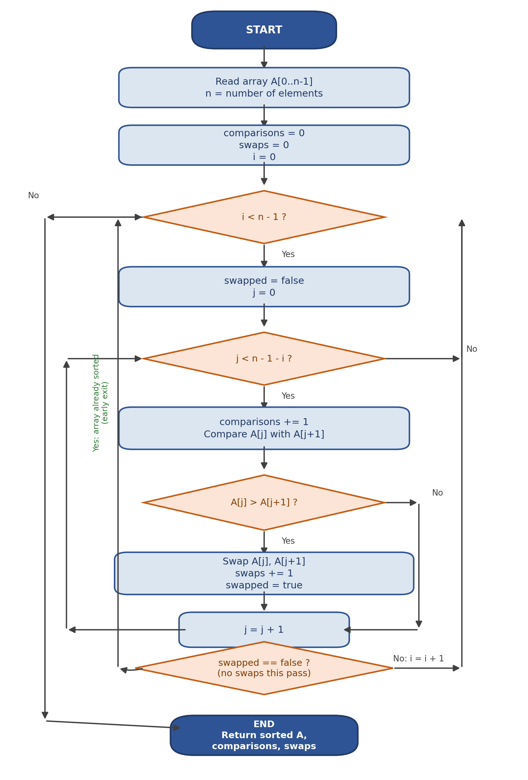

10. Step-by-Step Execution
The initial array is A = [11, 11, 25, 18, 18, 7]. Each pass below shows every adjacent comparison, whether a swap occurred, and the resulting array state.

Pass 1 — Array Entering This Pass: [11, 11, 25, 18, 18, 7]
Comparison | Result | Array After Step
Step 1: 11 vs 11 | No Swap (Equal) | 11, 11, 25, 18, 18, 7
Step 2: 11 vs 25 | No Swap | 11, 11, 25, 18, 18, 7
Step 3: 25 vs 18 | Swap | 11, 11, 18, 25, 18, 7
Step 4: 25 vs 18 | Swap | 11, 11, 18, 18, 25, 7
Step 5: 25 vs 7 | Swap | 11, 11, 18, 18, 7, 25
End of Pass 1: [11, 11, 18, 18, 7, 25] (Comparisons = 5, Swaps = 3)

Pass 2 — Array Entering This Pass: [11, 11, 18, 18, 7, 25]
Comparison | Result | Array After Step
Step 1: 11 vs 11 | No Swap (Equal) | 11, 11, 18, 18, 7, 25
Step 2: 11 vs 18 | No Swap | 11, 11, 18, 18, 7, 25
Step 3: 18 vs 18 | No Swap (Equal) | 11, 11, 18, 18, 7, 25
Step 4: 18 vs 7 | Swap | 11, 11, 18, 7, 18, 25
End of Pass 2: [11, 11, 18, 7, 18, 25] (Comparisons = 4, Swaps = 1)

Pass 3 — Array Entering This Pass: [11, 11, 18, 7, 18, 25]
Comparison | Result | Array After Step
Step 1: 11 vs 11 | No Swap (Equal) | 11, 11, 18, 7, 18, 25
Step 2: 11 vs 18 | No Swap | 11, 11, 18, 7, 18, 25
Step 3: 18 vs 7 | Swap | 11, 11, 7, 18, 18, 25
End of Pass 3: [11, 11, 7, 18, 18, 25] (Comparisons = 3, Swaps = 1)

Pass 4 — Array Entering This Pass: [11, 11, 7, 18, 18, 25]
Comparison | Result | Array After Step
Step 1: 11 vs 11 | No Swap (Equal) | 11, 11, 7, 18, 18, 25
Step 2: 11 vs 7 | Swap | 11, 7, 11, 18, 18, 25
End of Pass 4: [11, 7, 11, 18, 18, 25] (Comparisons = 2, Swaps = 1)

Pass 5 — Array Entering This Pass: [11, 7, 11, 18, 18, 25]
Comparison | Result | Array After Step
Step 1: 11 vs 7 | Swap | 7, 11, 11, 18, 18, 25
End of Pass 5: [7, 11, 11, 18, 18, 25] (Comparisons = 1, Swaps = 1)

Summary of Comparisons and Swaps
Pass | Array After Pass | Comparisons | Swaps
Pass 1 | 11, 11, 18, 18, 7, 25 | 5 | 3
Pass 2 | 11, 11, 18, 7, 18, 25 | 4 | 1
Pass 3 | 11, 11, 7, 18, 18, 25 | 3 | 1
Pass 4 | 11, 7, 11, 18, 18, 25 | 2 | 1
Pass 5 | 7, 11, 11, 18, 18, 25 | 1 | 1
Total | 7, 11, 11, 18, 18, 25 | 15 | 7
Total Comparisons = 5 + 4 + 3 + 2 + 1 = 15
Total Swaps = 3 + 1 + 1 + 1 + 1 = 7

11. Complexity Analysis
Case | Condition | Time Complexity
Best Case | Array already sorted; early-exit flag stops after 1 pass | O(n)
Average Case | Elements in random order | O(n²)
Worst Case | Array sorted in reverse order | O(n²)
This Dataset | Partially grouped duplicates; 25 and 7 far from final position | O(n²) — 15 comparisons, all 5 passes needed

- Best Case — O(n): only when the array is already sorted and an early-exit flag halts after a pass with zero swaps. This dataset does not hit the best case, since swaps occurred through Pass 4.
- Average Case — O(n²): for a randomly ordered array of n elements, roughly n²/4 comparisons and swaps are typically expected.
- Worst Case — O(n²): occurs for a reverse-sorted array, where every possible adjacent pair is out of order. Space complexity is O(1) in all cases since sorting is performed in place.
For the given dataset, all 5 passes and the full 15 comparisons (n(n−1)/2) were required, matching worst-case comparison behaviour, even though the two duplicate pairs slightly reduced the number of swaps. This shows that duplicate or grouped values only reduce swap count, never comparison count, in the standard version of Bubble Sort.

12. Correctness Analysis
Correctness is established through a loop invariant: “After the i-th pass of the outer loop, the last i elements of the array are in their final sorted positions and are ≥ every element in the unsorted prefix.”
- Initialization: Before the first pass (i = 0), zero elements are sorted, so the invariant holds trivially.
- Maintenance: During each pass, the inner loop compares every adjacent pair in the unsorted prefix and swaps when out of order, guaranteeing that the maximum value of that prefix is moved to its rightmost boundary by the end of the pass — exactly as observed when 25 moved to the last position after Pass 1.
- Termination: After n−1 = 5 passes, the invariant guarantees all 6 elements are in their correct sorted positions, which matches the final output [7, 11, 11, 18, 18, 25].
- Stability preserved: because the swap condition is strict (A[j] > A[j+1]), equal elements are never exchanged, so the relative order of the duplicate 11s and 18s from the input is provably preserved in the output.
These arguments formally establish that Bubble Sort, as executed here, produces a correctly and stably sorted array for the given input.

13. Test Cases
# | Input Array | Expected Output | Remarks / Result
1 | [11, 11, 25, 18, 18, 7] | [7, 11, 11, 18, 18, 25] | Primary dataset; 15 comparisons, 7 swaps — PASS
2 | [1, 2, 3, 4, 5] | [1, 2, 3, 4, 5] | Already sorted; best case, 4 comparisons, 0 swaps — PASS
3 | [5, 4, 3, 2, 1] | [1, 2, 3, 4, 5] | Reverse sorted; worst case, 10 comparisons, 10 swaps — PASS
4 | [7, 7, 7, 7] | [7, 7, 7, 7] | All duplicates; 6 comparisons, 0 swaps — PASS
5 | [9] | [9] | Single element; 0 comparisons, 0 swaps — PASS
6 | [] | [] | Empty array; algorithm exits loops immediately — PASS
Each test case was traced manually using the same nested-loop logic. All outputs matched the expected non-decreasing arrangement of the respective inputs, confirming that the algorithm is correctly implemented and generalises beyond the primary dataset.

14. Results
- Final Sorted Array: [7, 11, 11, 18, 18, 25]
- Total Comparisons: 15 (equal to n(n−1)/2 = 15 for n = 6)
- Total Swaps: 7
- Number of Passes Required: 5 (= n−1)
- Stability: Preserved — relative order of duplicate 11s and 18s unchanged from input to output.
- Observed Time Complexity for this Input: O(n²), consistent with worst-case comparison behaviour despite reduced swaps.

15. Conclusion
The Brute Force Bubble Sort algorithm was successfully applied to the dataset [11, 11, 25, 18, 18, 7], producing the correctly sorted output [7, 11, 11, 18, 18, 25] after 5 passes, 15 comparisons, and 7 swaps. The analysis shows that Bubble Sort's strict greater-than comparison guarantees stability, so duplicate values are never swapped and their relative order is preserved. Partially grouped duplicate blocks (11, 11 and 18, 18) reduced the total swap count by avoiding unnecessary exchanges between equal elements, but they did not reduce the number of comparisons or passes, since the extreme values 25 and 7 still forced the algorithm through comparison-heavy, worst-case-like behaviour. Overall, the exercise confirms that Bubble Sort's O(n²) time complexity is governed primarily by the position of extreme elements rather than by the presence of duplicates, while stability and in-place O(1) space usage remain its defining structural properties.

